Concrete Strength Prediction Using Machine Learning

A Project Report submitted in partial fulfillment of the requirements for the award of the degree of,
BACHELOR OF TECHNOLOGY IN
COMPUTER SCIENCE AND ENGINEERING

Submitted by:

ANUSHA KAPPALA 322010303058
G SAI LALITHA SHALINI 322010303052
LALITH KUMAR B 322010303013
YASWANTH TALANKI 322010303015

Under the esteemed guidance of
Dr. Venkatasubramanian Adhinarayanan
Associate Professor, CSE Dept

Department of Computer Science & Engineering,
GITAM SCHOOL OF TECHNOLOGY
GANDHI INSTITUTE OF TECHNOLOGY AND MANAGEMENT
(Deemed to be University) Bengaluru Campus.
March 2024
DEPARTMENT OF COMPUTER SCIENCE AND ENGINEERING

GITAM SCHOOL OF TECHNOLOGY

GITAM
(Deemed to be University)

CERTIFICATE

This is to certify that the project report entitled “Concrete Strength Prediction using Machine Learning” is a bonafide record of work carried out by ANUSHA KAPPALA(322010303058), G SAI LALITHA SHALINI(322010303052), LALITH KUMAR B(322010303013), YASWANTH T(322010303015) submitted in partial fulfillment of the requirement for the award of the degree of Bachelors of Technology in Computer Science and Engineering.

Project Guide Head of the Department

SIGNATURE OF THE GUIDE SIGNATURE OF THE HOD

Dr. Venkatasubramanian Adhinarayanan Dr.Vamsidhar Yendapalli
Associate Professor, CSE Dept Professor, CSE Dept

DEPARTMENT OF COMPUTER SCIENCE AND ENGINEERING

GITAM SCHOOL OF TECHNOLOGY

GITAM
(Deemed to be University)
DECLARATION

We, hereby declare that the project report entitled “Concrete Strength Prediction using Machine Learning” is an original work done in the Department of Computer Science and Engineering, GITAM School of Technology, GITAM (Deemed to be University) submitted in partial fulfillment of the requirements for the award of the degree of B.Tech. in Computer Science and Engineering. The work has not been submitted to any other college or University for the award of any degree.

Date:

REGISTRATION NO: NAME SIGNATURES

322010303058 ANUSHA KAPPALA
322010303052 G SAI LALITHA SHALINI
322010303013 LALITH KUMAR B
322010303015 YASWANTH TALANKI
DEPARTMENT OF COMPUTER SCIENCE AND ENGINEERING

GITAM SCHOOL OF TECHNOLOGY

GITAM
(Deemed to be University)
ACKNOWLEDGEMENT

The satisfaction and euphoria that accompany the successful completion of any task would be incomplete without the mention of the people who made it possible, whose consistent guidance and encouragement crowned our efforts with success.
We consider it our privilege to express our gratitude to all those who guided us in the completion of the project.
We express our gratitude to Director Prof. Basavaraj Gundappa Katageri for having provided us with the golden opportunity to undertake this project work in their esteemed organization.
We sincerely thank Dr. Y. Vamshidhar, HOD, Department of Computer Science and Engineering, Gandhi Institute of Technology and Management, Bengaluru for the immense support given to us.
We express our gratitude to our project guide DR. Venkatasubramanian Adhinarayanan, Associate Professor, CSE Dept, Department of Computer Science and Engineering, Gandhi Institute of Technology and Management, Bengaluru, for their support, guidance, and suggestions throughout the project work.

Name of the Student Registration Number
ANUSHA KAPPALA 322010303058
G SAI LALITHA SHALINI 322010303052
LALITH KUMAR B 322010303013
YASWANTH TALANKI 322010303015
DEPARTMENT OF COMPUTER SCIENCE AND ENGINEERING

GITAM SCHOOL OF TECHNOLOGY

GITAM
(Deemed to be University)

ABSTRACT

Accurately predicting concrete strength is a big challenge in the construction industry due to its complex composition. Traditional methods are costly and often fall short of forming precise relationships between concrete ingredients and strength.
Using data from concrete tests, we found that these AI techniques can create reliable strength predictions without expensive lab experiments, which is a big win for the construction materials industry.
Objective: The primary objective of this project is to develop a highly accurate and efficient model capable of estimating concrete compressive strength based on various input parameters. The proposed model aims to outperform traditional empirical methods and non-destructive testing techniques.

TABLE OF CONTENTS

Title Page No.
Certificate 2
Declaration 3
Acknowledgment 4,5
Abstract 6
Table of Contents 7,8
List of Figures 9
Introduction 10,11
Literature Survey 12-14
Software and Hardware Specifications
Software Requirements 15
Hardware Requirements 15
Specific Requirements
Functional Requirements 16
Non-Functional Requirements 17
Problem Statement 18
Designing
System Architecture 19
DFD(Level-1) 21
DFD(Level-2) 22
Class Diagram 23
Component Diagram 24
Use case Diagram 25
List of Modules 26,27
Implementation 28,29
Code 30
Code Explanation 31,32
Testing 33,34
Experiment Results 35
Performance 36
Training State 36
Error Histogram 37
Regression 38
Conclusion 39
Future Work 40
References 41,42

LIST OF FIGURES

Title Page No.

System Architecture 19

Structure of Neuron 20

Calculation of Compressive Strength on a Block 21

Data Flow Diagram(Level-1) 21

Data Flow Diagram(Level-2) 22

Class Diagram 23

Component Diagram 24

Use Case Diagram 25

Code executed in Matlab 33

Formulae to Calculate Errors 34

Neural Networking Training 35

Neural Networking Training Performance 36

Neural Networking Training State 36

Neural Networking Training Error Histogram 37

Neural Networking Training Regression 38

INTRODUCTION:

- Concrete strength is the capacity of concrete to withstand applied forces without breaking. It's measured as compressive strength, which indicates the maximum load a concrete sample can bear under compression.
- Common strength grades for concrete include:
- Low-Strength Concrete: Typically less than 2,500 psi (17 MPa).
- Standard-Strength Concrete: Ranges from 2,500 psi (17 MPa) to 6,000 psi (41 MPa).
- High-Strength Concrete: Exceeds 6,000 psi (41 MPa).
- Ultra-High-Strength Concrete: Can exceed 20,000 psi (138MPa).

What are the parameters to be considered?
- Concrete strength is influenced by various factors, including the mix proportions (the ratio of cement, aggregates, water, and additives), curing conditions (temperature and moisture during the curing period), and the quality of materials used.
- It's essential to design and test concrete mixes to achieve the required strength for a particular construction project to ensure its safety and durability.

How do we predict concrete strength traditionally?
- Concrete strength can be tested in the laboratory by casting concrete cylinders or cubes, curing them under controlled conditions, and then subjecting them to compression tests.
- In the field, non-destructive testing methods like rebound hammer testing or ultrasonic testing can also be used to estimate concrete strength without damaging the structure.
To predict concrete strength:
1. Develop a proper mix design.
2. Test raw materials for quality.
3. Maintain strict quality control.
4. Ensure proper curing methods.
5. Regularly test compressive strength.
6. Consider maturity methods or NDT.
7. Rely on past experience and data.
8. Adjust for environmental factors.
Traditional methods for predicting concrete strength have drawbacks:
- Expensive and Time-Consuming: They require costly, time-intensive testing processes.
- Destructive: Testing destroys concrete samples, leading to material waste.
- Long Wait: Waiting 28 days for results can delay projects.
- Limited Data: Only provide data at specific time points.
- Inaccuracy: Human error and variations can lead to imprecise results.
- Environmental Impact: Sample preparation and disposal have environmental effects.
Modern AI methods offer more efficient, non-destructive, and accurate alternatives.

LITERATURE SURVEY

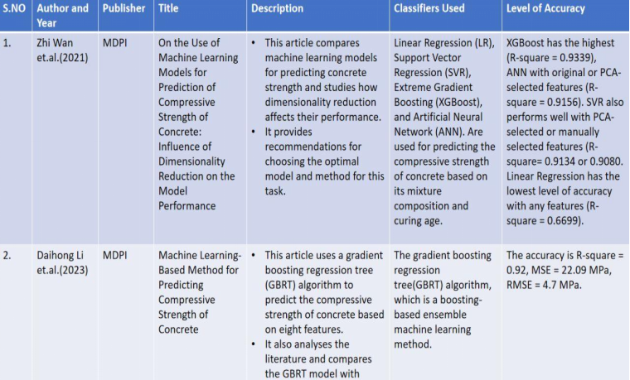
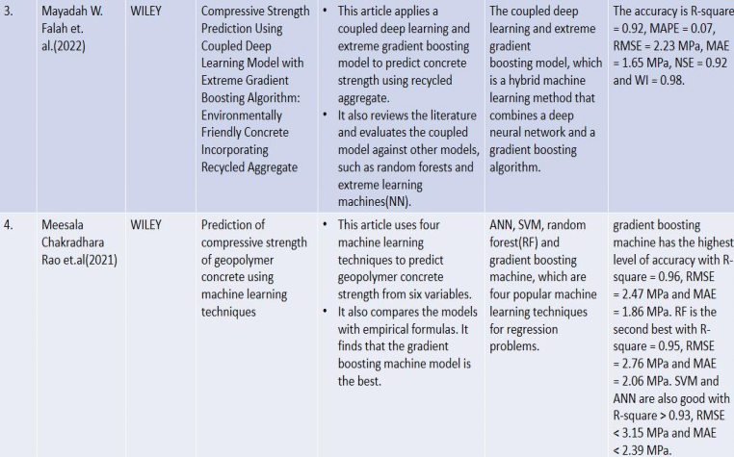
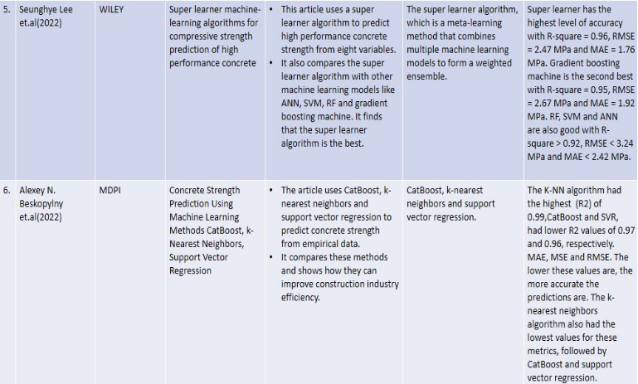
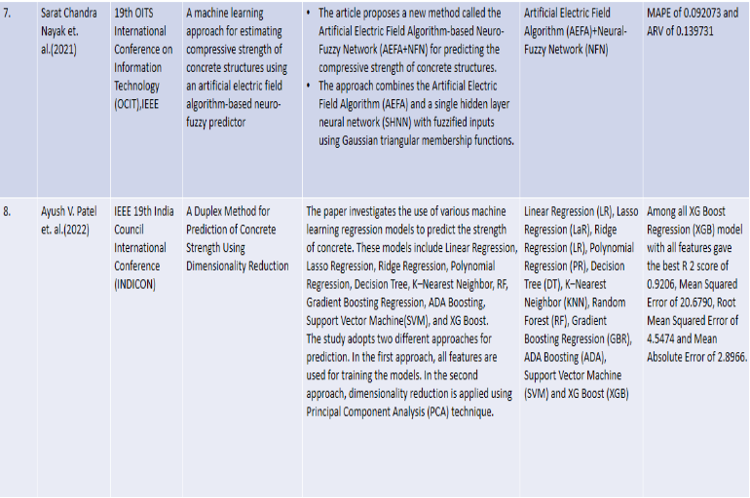

SOFTWARE AND HARDWARE SPECIFICATIONS

Software Requirements:
- MATLAB (version R2018a) - MATLAB provides extensive support for machine learning algorithms and data analysis.
- MATLAB Toolboxes:
  - Statistics and Machine Learning Toolbox - For implementing and training machine learning models.
  - Curve Fitting Toolbox - For fitting regression models to data.
MATLAB Live Editor or MATLAB IDE - For code development, visualization, and documentation.

Hardware Requirements:
- Processor: Intel Core i5 or equivalent AMD processor (or higher) for efficient computation.
- Memory (RAM): 8 GB RAM or higher for handling large datasets and running machine learning algorithms.
- Storage: At least 100 GB of free disk space for storing datasets, MATLAB scripts, and related files.
- Internet Connection: Stable internet connection for accessing online resources, MATLAB Central, and documentation.

Specific Requirements:

Functional Requirements:
Data Collection:
  - The system should be able to collect concrete strength data from various sources, including laboratory experiments and field tests.
  - It should support the acquisition of diverse features such as cement type, water-cement ratio, curing time, etc.
- Data Preprocessing:
  - The system should preprocess the collected data to handle missing values, outliers, and inconsistencies.
  - It should perform feature scaling, normalization, and encoding as required for input to machine learning models.
- Model Training and Evaluation:
  - The system should train machine learning models using appropriate algorithms such as regression, decision trees, or neural networks.
  - It should evaluate model performance using metrics like Mean Absolute Error (MAE), Mean Squared Error (MSE), or R-squared (R2) score.
- Prediction:
  - The system should allow users to input concrete mixture parameters.
  - It should predict the compressive strength of concrete based on the input parameters using the trained machine learning model.
- Visualization:
  - The system should provide visualizations such as scatter plots, histograms, or regression plots to analyze the relationship between input features and concrete strength.
Non-Functional Requirements:
- Performance:
  - The system should respond to user queries and predictions within a reasonable time frame (e.g., less than 1 second).
  - It should be capable of handling large datasets efficiently without significant slowdowns.
- Usability:
  - The system should have an intuitive user interface for easy interaction and input of concrete mixture parameters.
  - It should provide clear and informative visualizations to aid in data analysis and interpretation.
- Reliability:
  - The system should be robust and reliable, with minimal downtime or errors during operation.
  - It should handle unexpected inputs gracefully and provide informative error messages when necessary.
- Scalability:
  - The system should be scalable to accommodate future enhancements, such as adding support for additional features or integrating with new data sources.
- Security:
  - The system should implement security measures to protect sensitive data and prevent unauthorized access.
  - It should adhere to best practices for data encryption, authentication, and access control.

PROBLEM STATEMENT:
The construction industry heavily relies on accurate predictions of concrete strength to ensure structural integrity and safety in building projects. Traditional methods of predicting concrete strength based on mixed design parameters and laboratory tests are time-consuming and often require extensive expertise. Additionally, these methods may not account for all factors influencing concrete strength, leading to inaccuracies in predictions.
To address these challenges, this project aims to develop a machine learning-based solution for predicting concrete strength based on input parameters such as cement type, water-cement ratio, curing time, and aggregate properties. By leveraging historical data from concrete mix designs and corresponding strength test results, the project seeks to train and evaluate machine learning models capable of accurately predicting the compressive strength of concrete.
The key objectives of the project include:
- Collecting and preprocessing a diverse dataset of concrete mix designs and associated strength test results.
- Exploring and selecting appropriate machine learning algorithms for concrete strength prediction.
- Training and optimizing machine learning models using the prepared dataset to achieve high prediction accuracy.
- Evaluating model performance using relevant metrics and validation techniques to ensure reliability and generalization capability.
- Implementing a user-friendly interface to enable users to input concrete mixture parameters and obtain real-time predictions of concrete strength.
By successfully addressing these objectives, the project aims to provide a valuable tool for engineers, architects, and construction professionals to make informed decisions regarding concrete mix designs, optimize construction processes, and ensure the durability and safety of built structures.
DESIGNING:
System Architecture:
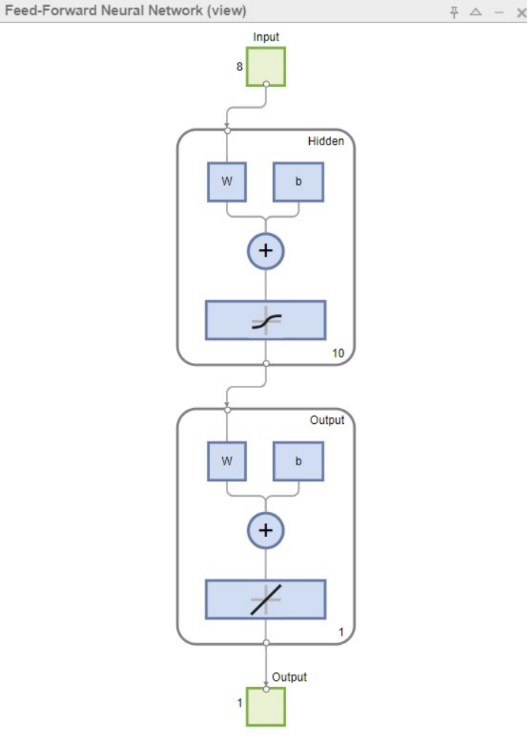
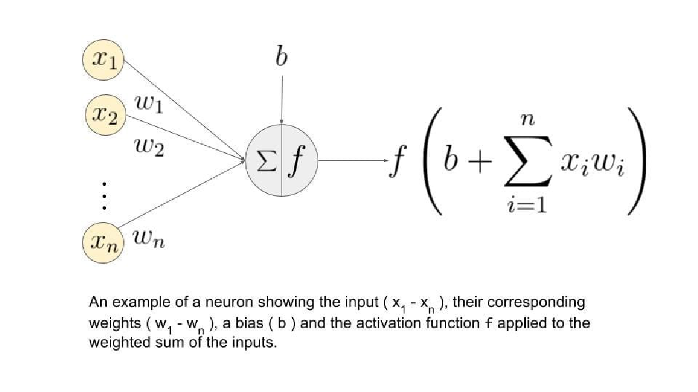

Attribute Information:
- Cement (component 1) -- kg in a m3 mixture
- Blast Furnace Slag (component 2) -- kg in a m3 mixture
- Fly Ash (component 3) -- kg in a m3 mixture
- Water (component 4) -- kg in a m3 mixture
- Superplasticizer (component 5) -- kg in a m3 mixture
- Coarse Aggregate (component 6) -- kg in a m3 mixture
- Fine Aggregate (component 7) -- kg in a m3 mixture
- Age -- Day (1~365)
- Concrete compressive strength -- MPa(megapascals) -- Output Variable

Compressive Strength(output variable):
- Compressive strength is calculated by dividing the maximum compressive load taken by the specimen by its cross-sectional area.
- Compressive strength compressive load/ cross-sectional area
- Calculation of Output variable:
- The cross-sectional area of the 15 cm cube is 15cm*15cm225cm^2.
- Compressive strength 90 tones
- Compressive strength 90*1000/225400kg/cm^2.
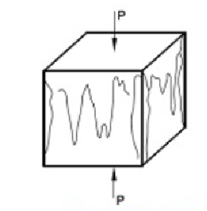

DFD(Level-1)

- 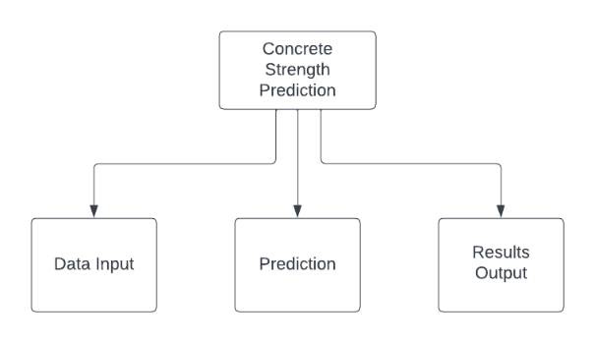

DFD(Level-2)

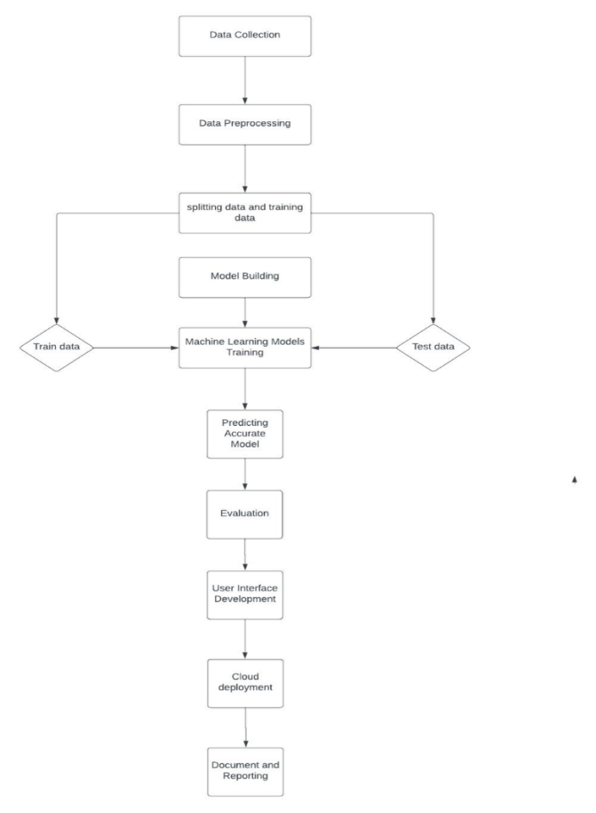

UML Diagrams:
Class Diagram:
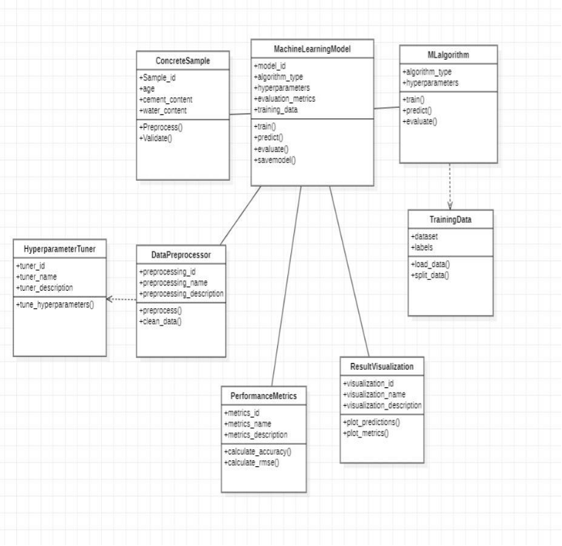

Component diagram:
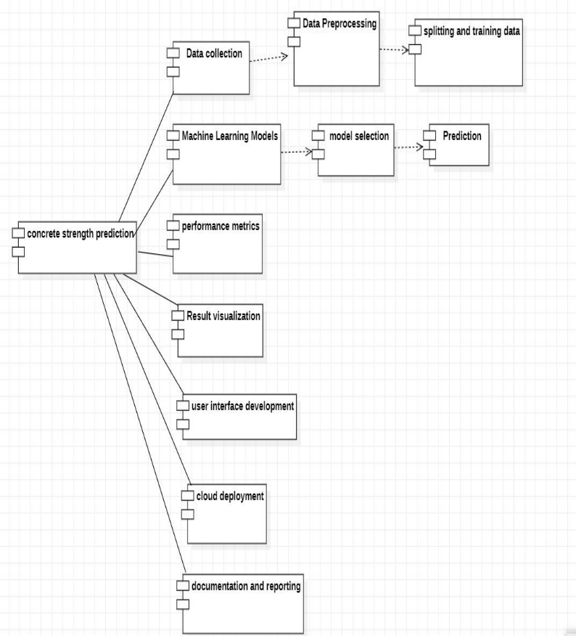

Use-case diagram:

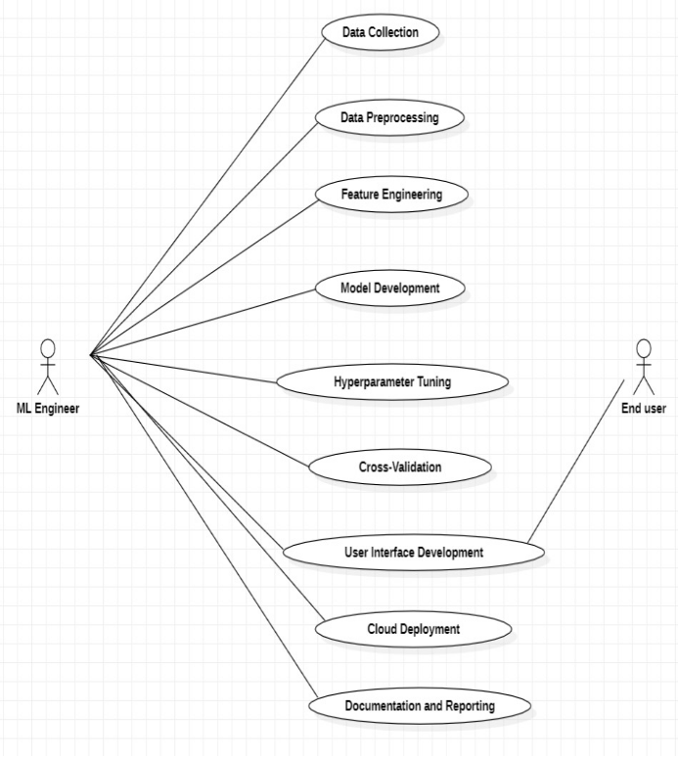
LIST OF MODULES WITH DESCRIPTIONS
- Data Collection Module:
This module gathers a diverse dataset of concrete mix designs and corresponding concrete strength values from various sources, including construction sites, research papers, and industry databases.
- Data Preprocessing Module:
The data preprocessing module cleans and prepares the dataset for analysis. It handles missing values, removes noise, and normalizes the input features to ensure consistent scaling across different parameters.
- Feature Engineering Module:
This module analyses the dataset to identify the most informative input features and creates new composite features based on expert knowledge to improve the model's accuracy.
- Model Development Module:
The model development module involves selecting and implementing machine learning algorithms, such as Artificial Neural Networks (ANNs), Regression, Support Vector Machines (SVM), or Gradient Boosting, to develop the concrete strength prediction model.
- Hyperparameter Tuning Module:
This module fine-tunes the hyperparameters of the selected machine-learning algorithms to optimize the model's performance and prevent overfitting.
- Cross-Validation Module:
The cross-validation module performs k-fold cross-validation to assess the model's generalization capabilities and validate its accuracy on different subsets of the dataset.
- User Interface Development Module:
This module creates a user-friendly application or API that allows engineers and construction professionals to input concrete mix parameters and obtain real-time concrete strength predictions.
- Cloud Deployment Module:
This module deploys the final model and user interface in the cloud to ensure accessibility and scalability for widespread use.
- Documentation and Reporting Module:
The documentation and reporting module compiles all the project findings, including data sources, preprocessing steps, model architecture, and evaluation results, into a comprehensive report summarizing the project's outcomes.

IMPLEMENTATION:
  - Open MATLAB:
    - Launch MATLAB on your computer. You should see the MATLAB Command Window and the MATLAB Workspace.
  - Navigate to the Directory Containing Your Dataset:
    - Use the cd command in the MATLAB Command Window to navigate to the directory where your dataset file (e.g., 'concrete.csv') is located. For example:cd 'C:\Path\To\Your\Directory'
  - Write the MATLAB Code:
    - Write your MATLAB code in the MATLAB Editor or any text editor you choose. Alternatively, you can copy the provided MATLAB code snippet into the MATLAB Editor.
  - Save the MATLAB Code:
    - Save your MATLAB code file with an appropriate name and the .m extension. For example, you can save it as concrete_prediction.m.
  - Run the MATLAB Code:
    - To execute the code, you can either:
      - Press the "Run" button in the MATLAB Editor toolbar.
      - Type the name of your MATLAB code file (without the .m extension) in the MATLAB Command Window and press Enter.
  - Monitor Execution in the Command Window:
    - The MATLAB Command Window will display the output and any error messages generated during code execution. Make sure to monitor this window for any issues or warnings.
  - Interact with the Generated Outputs:
    - After code execution, you can interact with the generated outputs as specified in your MATLAB code. For example, you can view the neural network structure using the view(net) command or analyze the performance metrics.
  - Debug and Modify Code (if Necessary):
    - If you encounter any errors or unexpected behavior, debug your code by examining error messages and checking variable values. Make necessary modifications to your code and rerun it as needed.
  - Save Results and Exit MATLAB:
    - Once you are satisfied with the results, you can save any generated plots, variables, or workspace data. You can also save your MATLAB code file if you made any changes. Finally, exit MATLAB by closing the MATLAB Command Window or selecting "Exit" from the MATLAB menu.

CODE:
close all;
clc;
A=readmatrix('concrete.csv');
x=A(:,1:8)';
t=A(:,9)';
trainFcn='traingd';
hiddenlayersize=10;
net = feedforwardnet(hiddenlayersize,trainFcn);
net.divideParam.trainRatio=70/100;
net.divideParam.valRatio=15/100;
net.divideParam.testRatio=15/100;
[net,tr]=train(net,x,t);
y=net(x);
e=gsubtract(t,y);
performance=perform(net,t,y);
view(net)

CODE EXPLANATION:
Import Data:
  - A=readmatrix('concrete.csv');: This line reads the data from the 'concrete.csv' file and stores it in a matrix A.
- Data Preparation:
  - x=A(:,1:8)';: This line extracts the input features (columns 1 to 8) from matrix A and transposes it to arrange data in a suitable format for the neural network. Each column of x represents a feature, and each row represents a sample.
  - t=A(:,9)';: This line extracts the target variable (column 9) from matrix A and transposes it. This variable represents the target output, which in this case is the strength of concrete.
- Neural Network Configuration:
  - trainFcn='traingd';: This line defines the training function for the neural network. 'traingd' stands for gradient descent training algorithm, which is a type of optimization algorithm commonly used in training neural networks.
  - hiddenlayersize=10;: This line defines the number of neurons in the hidden layer of the neural network. In this case, there are 10 neurons in the hidden layer.
- Neural Network Creation:
  - net = feedforwardnet(hiddenlayersize,trainFcn);: This line creates a feedforward neural network with one hidden layer. The number of neurons in the hidden layer is specified by hiddenlayersize, and the training function is specified by trainFcn.
- Data Division:
  - net.divideParam.trainRatio=70/100;: This line sets the training data ratio to 70% of the total dataset.
  - net.divideParam.valRatio=15/100;: This line sets the validation data ratio to 15% of the total dataset.
  - net.divideParam.testRatio=15/100;: This line sets the testing data ratio to 15% of the total dataset. These ratios define how the dataset will be split into training, validation, and testing sets.
- Neural Network Training:
  - [net,tr]=train(net,x,t);: This line trains the neural network (net) using the input features (x) and target output (t). The training progress is stored in the tr structure.
- Neural Network Evaluation:
  - y=net(x);: This line calculates the output (y) of the neural network for the input data (x).
  - e=gsubtract(t,y);: This line calculates the error (e) between the target output (t) and the predicted output (y).
  - performance=perform(net,t,y);: This line calculates the performance of the neural network based on the provided targets (t) and outputs (y).
- Visualization:
  - view(net): This line opens a graphical user interface (GUI) that allows visualization of the neural network architecture, including the input, hidden, and output layers, as well as the connections between neurons.

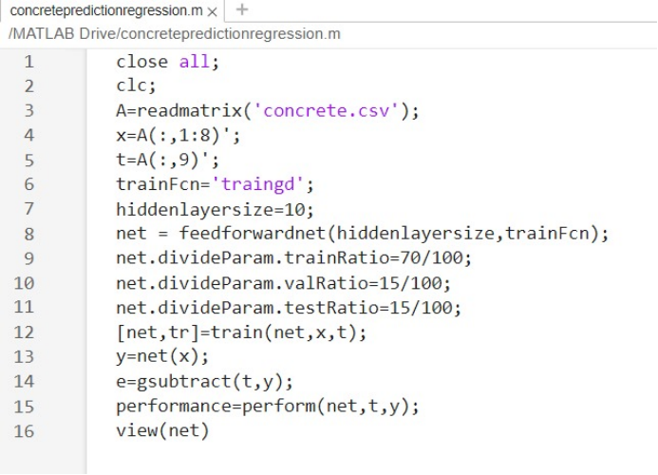

TESTING:
We have conducted thorough testing using a separate dataset, evaluating the performance of our machine-learning models for concrete strength prediction. Our analysis includes metrics such as Mean Absolute Error, Mean Squared Error, and coefficient of determination. Visualizations comparing predicted and actual values have been generated, and we have performed an in-depth analysis of prediction errors to identify any patterns or trends. Results have been documented and are available for review and formulae are mentioned here,

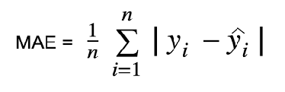
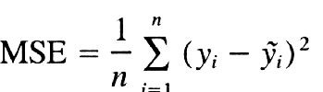
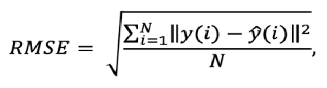
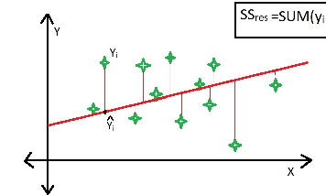

EXPERIMENTAL RESULTS:

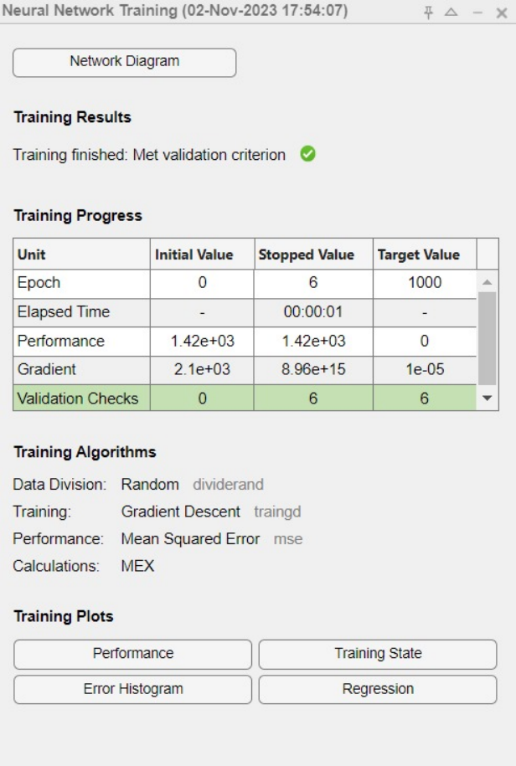

PERFORMANCE:
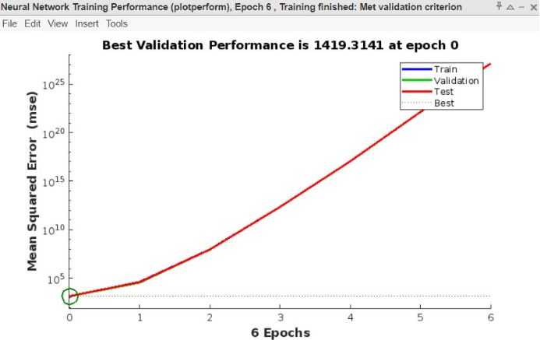
TRAINING STATE:
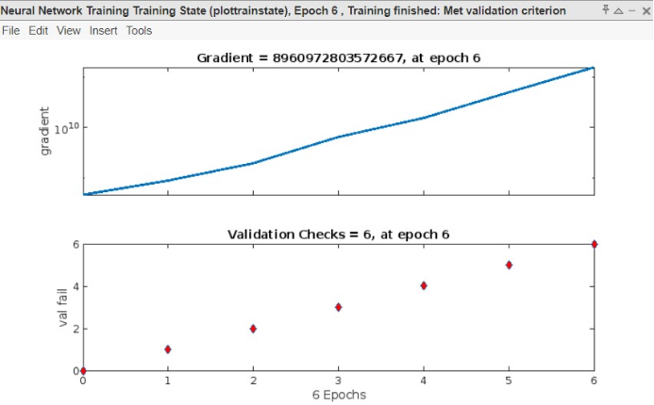

ERROR HISTOGRAM :
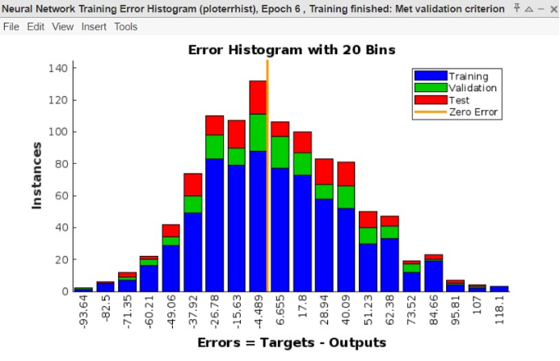

REGRESSION:
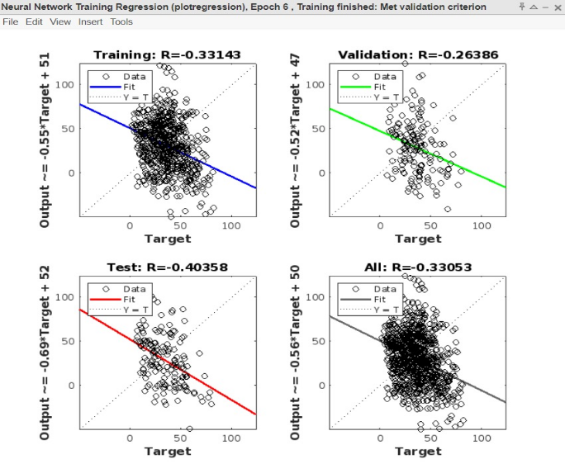

CONCLUSION:
In conclusion, our project successfully developed and evaluated machine learning models for predicting concrete strength based on input parameters. Through rigorous testing and analysis, we have demonstrated the effectiveness of our models in accurately estimating concrete strength. The predictive performance metrics indicate satisfactory accuracy, with minimal error rates across the testing dataset. Our findings suggest that machine learning techniques hold promise for enhancing concrete strength prediction in the construction industry. Moving forward, further refinements and optimizations can be explored to improve model robustness and generalization capability. Overall, this project contributes valuable insights towards the advancement of predictive modeling in construction engineering, facilitating informed decision-making and ensuring structural integrity in building projects

FUTURE WORK:

In our upcoming project updates, we will develop an API to provide engineers with streamlined access to concrete strength data. The goal is to empower engineers across industries by offering a reliable tool for assessing concrete strength in diverse applications. The API goes beyond data retrieval, allowing engineers to input parameters for precise strength assessments based on industry standards.
Additionally, we plan to deploy the project on a cloud platform, ensuring global accessibility and efficient scalability. This move towards cloud deployment signifies a significant stride in integrating technology and engineering practices, fostering innovation in construction and infrastructure.
In future work, several avenues could be explored to enhance the project's contributions to concrete strength prediction using machine learning. Firstly, integrating additional features such as environmental factors or aggregate properties could augment the model's predictive capabilities. Further refinement through model fine-tuning and hyperparameter optimization techniques could boost predictive accuracy and performance.
Additionally, exploring data augmentation methods to increase dataset diversity and dynamic model updating mechanisms for real-time adaptation could improve model robustness. Uncertainty quantification techniques could provide insights into prediction reliability, while deployment in real-world settings would validate practical feasibility and usability. Collaboration with industry stakeholders and validation against existing standards would ensure alignment with industry requirements. Enhancing model interpretability and long-term performance monitoring would foster trust and facilitate continuous improvement. These future directions promise to advance concrete strength prediction, ultimately contributing to safer and more efficient construction practices.
REFERENCES:
1)Ahmed et al.,2022d H.U. Ahmed, A.S. Mohammed, A.A. Mohammed Proposing several model techniques, including ANN and M5P-tree, to predict the compressive strength of geopolymer concretes incorporated with nano-silicaView Article
2)Ahmed et al.,2022d H.U. Ahmed, A.S. Mohammed, A.A. Mohammed Multivariable models, including artificial neural network and M5P-tree, to forecast the stress at the failure of alkali-activated concrete at ambient curing conditions and various mixture proportionsView Article
3) A. Kumar, H. C. Arora, N. R. Kapoor et al., “Compressive strength prediction of lightweight concrete: machine learning models,” Sustainability, vol. 14, no. 4, p. 2404, 2022.View Article
4)S. Chithra, S. S. Kumar, K. Chinnaraju, and F. Alfin Ashmita, “A comparative study on the compressive strength prediction models for High-Performance Concrete containing nano silica and copper slag using regression analysis and Artificial Neural Networks,” Construction and Building Materials, vol. 114, pp. 528–535, 2016.View Article
5) S. Kekez, “Application of artificial neural networks for prediction of mechanical properties of CNT/CNF reinforced concrete,” Materials, vol. 14, no. 19, p. 5637, 2021.View Article
6) H. W. Song, A. Ahmad, F. Farooq et al., “Predicting the compressive strength of concrete with fly ash admixture using machine learning algorithms,” Construction and Building Materials, vol. 308, Article ID 125021, 2021.View Article
7) H. I. Erdal, O. Karakurt, and E. Namli, “High performance concrete compressive strength forecasting using ensemble models based on discrete wavelet transform,” Engineering Applications of Artificial Intelligence, vol. 26, no. 4, pp. 1246–1254, 2013.View Article
8) Y. Ren, J. Huang, Z. Hong, et al., “Image-based concrete crack detection in tunnels using deep fully convolutional networks,” Construction and Building Materials, vol. 234, Article ID 117367, 2020.View Article
9)N. Hong-Guang and J. Zong Wang, “Prediction of compressive strength of concrete by neural networks,” Cement and Concrete Research, vol. 30, no. 8, pp. 1245–1250, 2000.View Article

